Using this Template

This series of instructions explains how to use the template in a Microsoft Word environment.

Where Do I Put the Template.dotx File?

You need to navigate to this folder by using this path:

Library/Application Support/Microsoft/Office/User Templates/My Templates

Place it in the My Templates folder.

Applying the Template to a New Document

If you’re creating a new document for your RPG, you can do so in three different ways:

The Shortest Way

When you open Word, and if you placed the Template.dotx in your My Templates folder, it should show up as an option. Choose it! You can also click on File in the Menu Bar and choose New from Template.

The Other Way

Alternatively, you could save the template as a .docx file and use that as your starting point.

Applying the Template to an Existing Document

If you need to apply the template to an existing document for D&D Next, you can do the following:

* Open the document.
* Click on Tools in the Menu Bar.
* Click on Templates and Add-Ins in the pull-down menu.
* Click on Attach in the Templates and Add-ins window that pops up.
* Browse to where you placed the template file. My Templates is the default location.
* Click on Template.dotx and Open it.
* Check the box next to Automatically update document styles.
* Click OK.

After you do this, you need to check the file for the following things, and you might need to adjust them manually:

Add in the header and footer. Ensure that the styles are followed. You can do this by copying and pasting the header and footer from a properly styled existing document or by making a .docx file from the .dotx template file.

Understanding Purpose Of Built-In Styles

Using Styles

Open styles gallery

The text formatting in this document relies on Styles. Open the Styles gallery by going to the Home tab, then clicking on the pop-out arrow to open the Styles window:

After you do so, a floating Styles box will appear that looks like this. Drag it to the right side of screen to dock it as a sidebar. Very important: Before doing anything else, click on the Options button in the Styles pane and select the following options:

Applying styles

When using this template, do not format things manually, except for when you need to do something that doesn’t have a style (which will happen very rarely). Instead, when you need to change the format of any text, select the style you need from the Styles pane. The later pages of this template contain many examples and instructions for how to select and apply the correct styles to your document.

The thing you’re most likely to need to manually adjust is paragraph spacing, as you might find times you need more space before/after a particular style than the style automatically provides. To do this, go to Paragraph Settings; you may need to change the points before or after a particular paragraph, or to uncheck the box “Don’t add space between paragraphs of the same type.”

Use paragraph styles to bold/italicize

Rather than using the buttons on the ribbon (or Ctrl-B and Ctrl-I) to bold and italicize text, you can assign character styles to do the same. This may seem arduous at first, but has three primary benefits:

• Keeps Word from creating new temporary character styles for every style that you modify by bolding text. If you bold a word without using the “CHAR BOLD” style, Word will start showing a second “CORE BULLETS” style with the bold attribute added… and so on for every single style you add bold or italics to.

• Makes it safer to apply paragraph styles to large blocks of text without worrying about a particular word losing its bolding or italicization. It’ll always keep that character style on it once assigned.

• If you ever send your Word document to a layout designer for professional layout in InDesign, it’s easy for for them to migrate your text over to the final InDesign layout and easily see how words should be formatted.

|  |
| --- |
| Tip: Read the Official Style Guide!  The quick reference above focuses mainly on formatting text. In addition, you should be familiar with the official [D&D House Style Guide](https://www.dmsguild.com/product/267467/DMs-Guild-Creator-Resource--Style-Guide-Resources?affiliate_id=1650578) for fifth edition, freely available on the Dungeon Masters Guild. This contains a wealth of information about how to write for fifth edition. |

Page margins

Table

|  |  |  |
| --- | --- | --- |
| Margin | inches | cm |
| Top | 1” | 2.54 cm |
| Left | 0.8” |  |
| Bottom | 1” | 2.54 cm |
| Right | 0.8” |  |
| Header | 0.4” from the edge | 1.02 cm from the edge |
| Footer | 0.4” from the edge | 1.02 cm from the edge |

You should be aware of the styles that are in place in the document as you go. To see what should be available, in the Styles toolbox, you can use the List functionality to point the list to styles In Current Document to make it easier to see what you need to see. Please delete any styles that are no longer needed in the document; if you try to delete a style that is in use, look for the Select All option before you delete that style. (This option won’t be available if that style isn’t used in the document. Yes, this sounds strange. Welcome to templates.) You can select all instances of that style and change it to the preferred style before you delete the one that is not valid. Be aware that Word 2011 has some quirks still when it comes to deleting styles—sometimes you have to Clear Formatting to truly restyle text. Be mindful of styles as you go.

Columns: Go to Format in the Menu Bar. Choose Columns. Set them to two and give them 0.5” spacing. The Title style should remain as one column; tables might need to flow to one column.

Unformatted Text

The absolute best way to ensure that you have no lingering styles from older documents tainting your new document is to use this process.

WARNING: You will lose italics, bold, and other things that you want to keep, so use this only if you have the time (and preferably dual monitors) to go through and reformat characters as needed. This guarantees that you don’t have to contend with older styles, however, which is also a benefit.

* Copy the text you wish to paste.
* In the destination document, choose Edit in the menu bar and pick Paste Special. (Shortcut: Use Control-Command-V.)
* Choose Unformatted Text when given the option.
* Click OK.
* Compare your original document to the new document and make changes as needed.

If you use this template correctly, then when you apply an updated template to a document that uses the Template, it will make changes in styles quick and easy to implement

Creating Drop Cap

You can create a drop cap, like the one at the beginning of this paragraph, by highlighting the paragraph you want to apply it to. Next, click on Insert > Drop Cap > Drop Cap Options, change the font to what you want, and change “Lines to Drop” to 5. Finally, highlight the drop cap letter, and change the text color to “Red, Accent 1.” If the paragraph you’re applying it to is italicized, you’ll also have to toggle off the italics for the drop cap.

Using Images

Adding art to your supplement is one of the easiest ways to add polish. Here are some quick tips on how to make the most of Word’s picture tools.

However, keep in mind that putting a lot of images in your Word document will increase your PDF’s file size. You may even experience some slowness while editing the text within Word. Be sure to note the “Compress Images” section on the previous page for instructions on how to reduce your image file size before publishing.

Inserting Art

You can drag and drop art from the Windows File Explorer straight into Word, or click the Insert tab, then click pictures. Once it’s inserted and you click on the image, you’ll see a Picture Format toolbar appear.

Positioning Your Image

For almost all art, you’ll want to change the Wrap Text options to either Tight (wraps text around the shape of that image), Top and Bottom (makes text skip the lines it occupies), but otherwise lets you move it freely), Behind Text (allows you to freely position anywhere, and makes text appear in front of the image), or In Front of Text (allows you to freely position anywhere, and hides text behind it).

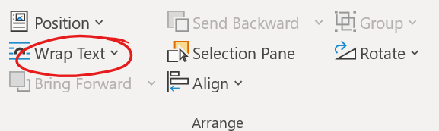

By default, Word tries to restrict your image to keep it within the page margins. To place an image outside them (as with a full-page-width image at the top or bottom of page, as common in official sourcebooks), you can either set it to appear Behind Text (which doesn’t wrap text), or you set it for Top and Bottom wrap, then uncheck the box for Move with Text (which allows you to put it in the margins of your page, but still easily wrap text around it).

Image Effects

While Word isn’t intended for photo manipulation, there are some basic effects it can add to your images. A few of the most useful are demonstrated here, with examples on the right of page.

Picture Styles

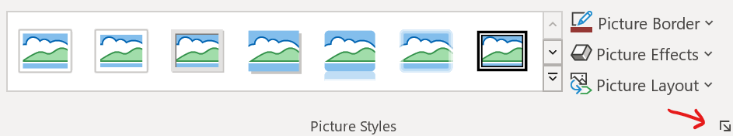You can select a wide range of Picture Styles from a dropdown menu, including frames, drop shadows, and faded edges. In addition, you can customize the styles by opening the Format Picture dialog box (see red arrow for where to click).

Artistic Effects

You can also do some quick “photomanipulation” to add art filters to your pictures, though the options are far more limited than a photo editor like Photoshop (paid) or GIMP (free) would allow.

Picture Styles: Simple Frame

Picture Styles: Drop Shadow: Blur: 10, Distance: 3

Picture Styles: Soft Edge Rectangle

Color: Set Transparent Color

Artistic Effects: Paint Brush

Hotkeys

For styles in this template hotkeys were assigned. In table below you can see all used hot-keyed styles.

General Microsoft Word hot keys

Those hot keys are very efficient with editing of layout of adventure or supplement. Better to know it.

Table

|  |  |
| --- | --- |
| Insert a field | Ctrl + F9 |
| Row break | Shift+Enter |
| Page break | Ctrl+Enter |
| Column break | Shift+Ctrl+Enter |
| Tab | Ctrl+Tab |
| Copy formatting | Shift+Ctrl+C |
| Paste formatting | Shift+Ctrl+V |
| Clear additional formatting | Ctrl+Space |
| Apply Symbol font to selected text | Shift+Ctrl+Q |
| Applying styles | Ctrl+Shift+S |
| Style | Alt+Ctrl+Shift+S |
| Autoformat | Alt+Ctrl+K |
| Normal | Ctrl+Shift+N |
| Heading 1 | Alt+Ctrl+1 |

Hot keys for styles in this template

In this template I applied custom hotkeys to styles which are built-in template to give ability to fast applying most used styles to text to increase speed of editing.

Table

|  |  |
| --- | --- |
| Style | Hotkeys |
| Basic Text | Ctrl+A,A |
| Basic Text Paragraph 1 | Ctrl+A,1 |
| Basic Text Paragraph 2 | Ctrl+A,2 |
| Chapter Title | Ctrl+C,1 |
| Subchapter Title | Ctrl+C,2 |
| Heading 1 TOC | Ctrl+H,1 |
| Heading 2 TOC | Ctrl+H,2 |
| Heading 3 TOC | Ctrl+H,3 |
| Basic Sidebar Heading | Ctrl+S,D |
| Basic Sidebar Text Regular | Ctrl+S,A |
| Basic Sidebar Text Regular Paragraph 2 | Ctrl+S,Q |
| Basuc Table Header | Ctrl+T,F |
| Basuc Table Heading | Ctrl+T,H |
| Basuc Table Heading Centered | Ctrl+T,G |
| Basic Table Text | Ctrl+T,T |
| Basic Table Text Paragraph 2 | Ctrl+T,Q |
| Char Bold | Ctrl+B,B |
| Char Italic | Ctrl+I,I |
| Char Sup | Ctrl+S,U |
| Red Colored | Ctrl+C,R |
| Blue Colored | Ctrl+C,B |
| Green Colored | Ctrl+C,G |
| Boxed Text | Ctrl+B,T |
| Aloud Text | Ctrl+A,T |
| Side Notes | Ctrl+S,T |
| Sidebar |  |
| Sidebar |  |
| Sidebar |  |

This section includes miscellaneous tips and tricks to help you get the most out of this template.

Importing Text With Other Formats

If you copy and paste text into this template from another document, it will likely import with different styles than the ones you need to use.

You can make changes en masse to other styles that come in with imported text:

Click on a paragraph holding the text you need to reformat—the Styles window will jump to that style.

Hover over that style and click the down arrow next to it.

Click “Select all # Instances.” When you do so, Word will think for a moment, then highlight all the times in the document that use that exact formatting.

With all the text that needs to change highlighted, click on the new style you want to switch it to—for example, the “5E – CORE BODY PARA2” style. Word will switch all that text to using the Core Body style with indented first lines. After that, it’s easy to go through and change the first paragraph of each section to correctly use the “5E – CORE BODY PARA1” style without the indent, while leaving the rest formatted with the proper indent.

How to Un-Italicize Epigraph Text

If you have a style that applies italics (or bold) to a block of text, but you need a portion of it to be formatted without it, you can (counterintuitively) un-italicize it by highlighting that text, then selecting the “*5E CHAR ITALIC” style. This will reverse the italicization on that paragraph. For example, this is useful if you need to un-italicize a word in an italicized epigraph.

Changing Font Size

The core body font size in this template is roughly equivalent to that of a Wizards of the Coast hardcover (even though this font is Merriweather 8 pt., this particular font is larger than Bookmania 9 pt., the font used in hardcovers). If you wish to increase the font size, you can do so by right-clicking on the “5E – CORE BODY PARA1” style and selecting Modify. On the Style Options screen that opens, change the font size dropdown box to 9-point font, then click OK. This will automatically change the Paragraph 2 style as well. You can change other styles (such as sidebar fonts) the same way.

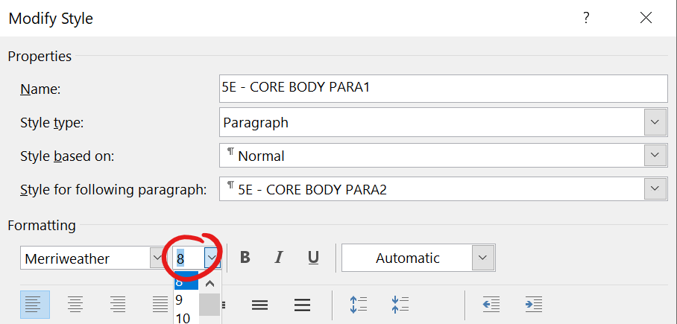

Paragraph vs. Character Styles

This template uses both paragraph and character styles. Paragraph styles affect the entire paragraph, and can’t be used to format just part of it. In contrast, character styles allow you to apply selective formatting (e.g. bold) to just a few characters if you wish, while leaving the underlying paragraph style untouched.

You can easily identify which are which in the Styles sidebar: the character styles are prefixed with an asterisk and appear at the top of your style list. You can also identify them by the icon Word displays to the right of that style name. Character styles have an “a” icon, paragraph styles have a “¶” icon.

Slow Performance

Depending on your computer, it may be slow to work with a Word document that has a lot of pictures embedded (as does this sample template). To work around this, don’t add any pictures until you’ve finished writing & layout.

Stat Blocks

Stat blocks of creatures and NPC are important part of many RPG materials. In this chapter different options to create it are presented – from simple text block to more complex variants.

В этой главе я привожу примеры различного оформления блоков статистики и модификации блоков статистики.

Basic Stat Block – текстовый блок статистики без использования таблиц или других элементов. Использует группу стилей Stat Block Basic

Playtest B&W Stat Block – не использующий цветовое оформление блок статистики, пригодный для использования в плейтестах или монохромных материалах. Использует группу стилей Playtest

Basic Stat Block Expanded – базовый блок статистики расширенный до всех возможных разделов для уникального НИП.

Universal Character Stat Block – попытка воссоздать шаблон записи данных о ИП, НИП, чудовищах в 3.5 редакции

V5 – сокращенный и упрощенный текстовый блок статистики

Short Pregenerated Character Template – Grim&Beadle продемонстрировали, что с помощью представления блока статистики можно оформлять и предсозданных персонажей.

Default Stat Block -

Expanded Default Stat Block -

Variant Stat Block -

Fancy Stat Block – во многом основанный на блоке статистики, созданным Лаурой. Использует группу стилей Fancy Stat Block

Сore 5e Stat Block -

Отдельно рассмотрим широкие или двух-колоночные блоки статистик

Fancy Two Column Stat Block – двух колоночный вариант стат блока, основанный на связи двух текстовых полей.

Another Two Column Stat Block -

Basic Two Column Stat Block -

Simple Table Two Column Stat Block -

Дополнительно приведены примеры оформления блоков описания заклинания и волшебных предметов.

Table Spell Block – табличный способ оформления описания заклинания.

Text Magic Item Description Block – текстовый способ оформления описания волшебного предмета.

Table Magic Item Description Block – описание волшебного предмета с использованием таблиц.

Structure of Stat Block in 5ed

Identity information

Main statistics

Ability Scores

Traits

Actions

Reactions

Legendary actions

Paragon actions

Lair

Regional effects

Roleplaying Information

Lair actions

Secondary Statistics

Figure Structure of default D&D 5ed Monster Stat Block

Identity Information consists of:

* Monster or NPC name
* Size
* Type (subtype)
* Alignment

Main statistics consists of:

* AC
* HP
* Speed

Ability scores includes

Block “Secondary Statistics” consist of such elements:

* Saving throws
* Skills

Block “Traits” begins after Ability scores and consists of:

Block “Actions” has main information about monster’s actions in combat. If monster has “Multiattack” action it must be listed first.

If monster has specific Reactions then block “Reactions” are used to describe it.

Some powerful monster has “Legendary actions”, which give them ability to act after someone turn. Usually if monster has “Legendary actions” then it also has “Legendary Resistance” trait.

Block “Legendary actions” begins from default phrase about number of legendary actions which have monster or NPC.

The %%Monster Name%% can take XXX legendary actions, choosing from the options below. Only one legendary action option can be used at a time and only at the end of another creature's turn. The %%Monster Name%% regains spent legendary actions at the start of its turn.

Paragon actions.

Block “Lair” has a description of lairr of monster.

Block “Lair actions” has a default phrase on beginning about using of lair actions followed by descriptions of lair actions (see below),

On initiative count 20 (losing initiative ties), the %%Monster Name%% takes a lair action to cause one of the following effects:

Block “Regional effects” has description of changes of nature and environment in close range from lair. Usually those regional effects can be used by monsters as another monster’s traits